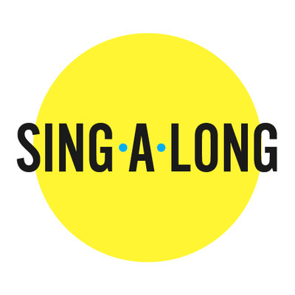

With Cantor Alicia

10:30 AM after Minyan

**September 19 – High Holy Days**

**Old classics & new melodies**

**Rosh Hashanah through Simchat Torah**

**November 11 – Music of the Shoah**

**How we remember Kristallnacht**

**December 19 – Chanukah Songs**

**Old & New**

**January 9 – Sounds of Shabbat**

**New to TJ or just love to sing? Learn the most loved melodies that we share on Shabbat**

**April 2 – Passover Seder Songs**

